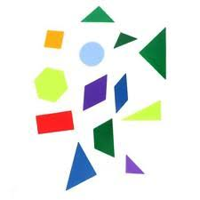
There’s More to Maths than Counting!
Maths is everywhere in the home. With the support of parents, children can grasp many mathematical concepts through their play.
Daily Routines
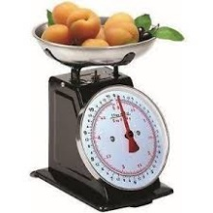
Let your child help you measure ingredients for a simple recipe; talk about how long it takes to cook; set a timer.
Use a calendar to count down the days to a birthday or special holiday.
Measure your child's height every month or so, showing how you use a measure stick or tape measure.
Talk about the days of the week and what happens when; talk about yesterday, today and tomorrow.
Sand and Water
Using sand and water to fill containers can develop mathematical concepts and language, e.g. heavy, light, empty, full, big, little, how much will it hold.
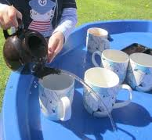
Make shapes and patterns with different objects in wet sand.
Give your child different sized containers to fill and empty at bathtime.
Dough
Use dough to make short, long, fat, thin shapes.
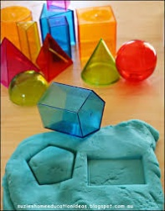
Make flat shapes with shape cutters; roll and form dough into 3-d shapes.
Physical Play
Building with blocks or playing with small world toys, e.g. cars, dinosaurs can help to develop sequencing by encouraging your child to sequence according to size, colour, use (e.g. bike, car, lorry).
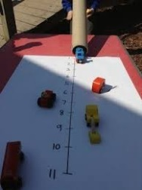
Playing with different sized blocks can help to develop an understanding of weight and dimensions.
Use junk, such as empty boxes and tubes to explore 3D shapes. Use large boxes that your child can get into.
Make an obstacle course with your child and use words such as under, over and through.
Use a wheelbarrow or bag to move objects. Talk to your child about things being lighter or heavier than each other.
Roll balls, cars down ramps. Talk to your child about how far they have travelled.
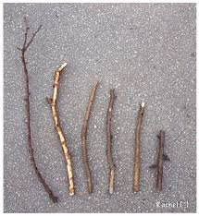
Out and About
Collect everyday items, e.g. stones, leaves, sticks, which your child can sort into shape, size, weight
Talk about time, such as “How long does it take to get to the park?”.
Go on a shape hunt and point out all the shapes you see, such as square windows or round wheels.
Hide objects and use clues to help your child to find them, such as “It’s under the hedge, next to the plant pot.
Town Street Playgroup 2018

